Fernando Gonzales-Vigil

Project 4

**Test Plan**

|  |  |  |  |  |  |
| --- | --- | --- | --- | --- | --- |
| **Test Case #** | **Input** | **Actual input** | **Expected Output** | **Actual Output** | **Did Test Pass?** |
| 1 | 3 id’s and 3 regular days | 1234 – 5  4567 – 0  9988 - 2 | 3 employees  7 days  2.333 average | 3 employees  7 days  2.333 average | YES |
| 2 | Negative or 0 employee number | -1, 0, -5, -9 | Does not exit the loop until positive number | “The number of employees must be 1 or more” | YES |
| 3 | Negative number for absent days | -1, -5 | Does not exit the loop until 0 or positive number | “The number of days must not be negative” | YES |
| 4 | 5 employees, different id’s, all 0 days | 788 – 0  3434 – 0  990 -0  1 – 0  9 - 0 | 5 employees  0 days  0 average | 5 employees  0 days  0 average | YES |

**Screen Output 1**

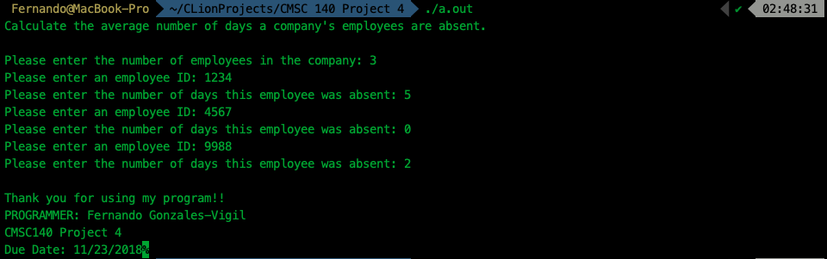

**File Output 1**

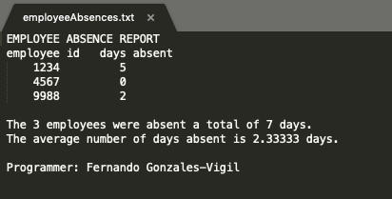

**Screen Output 2**

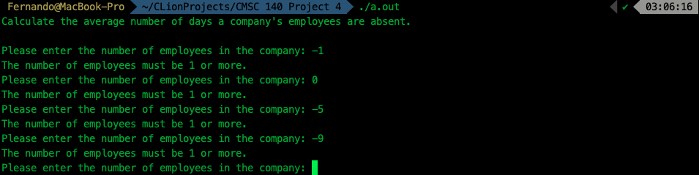

**File Output 2** > File empty

**Screen Output 3**

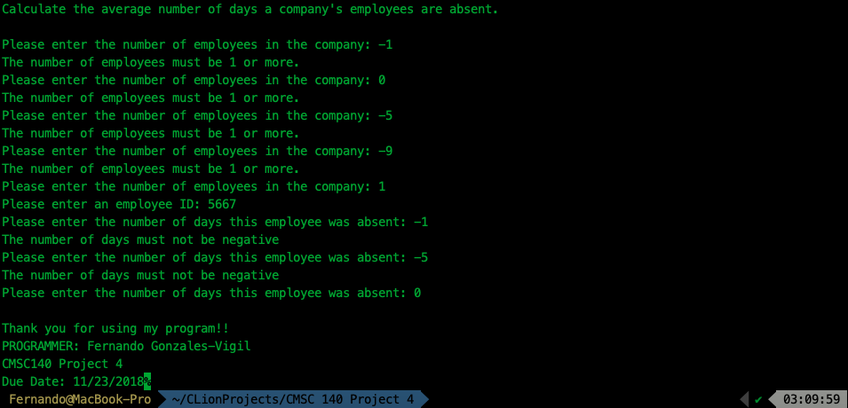

**File Output 3**

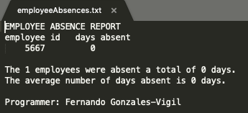

**Screen Output 4**

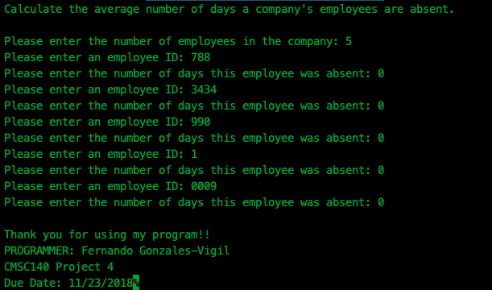

**File Output 4**

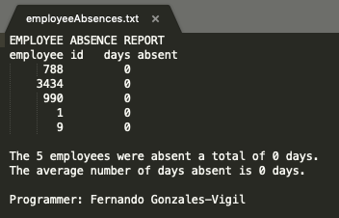

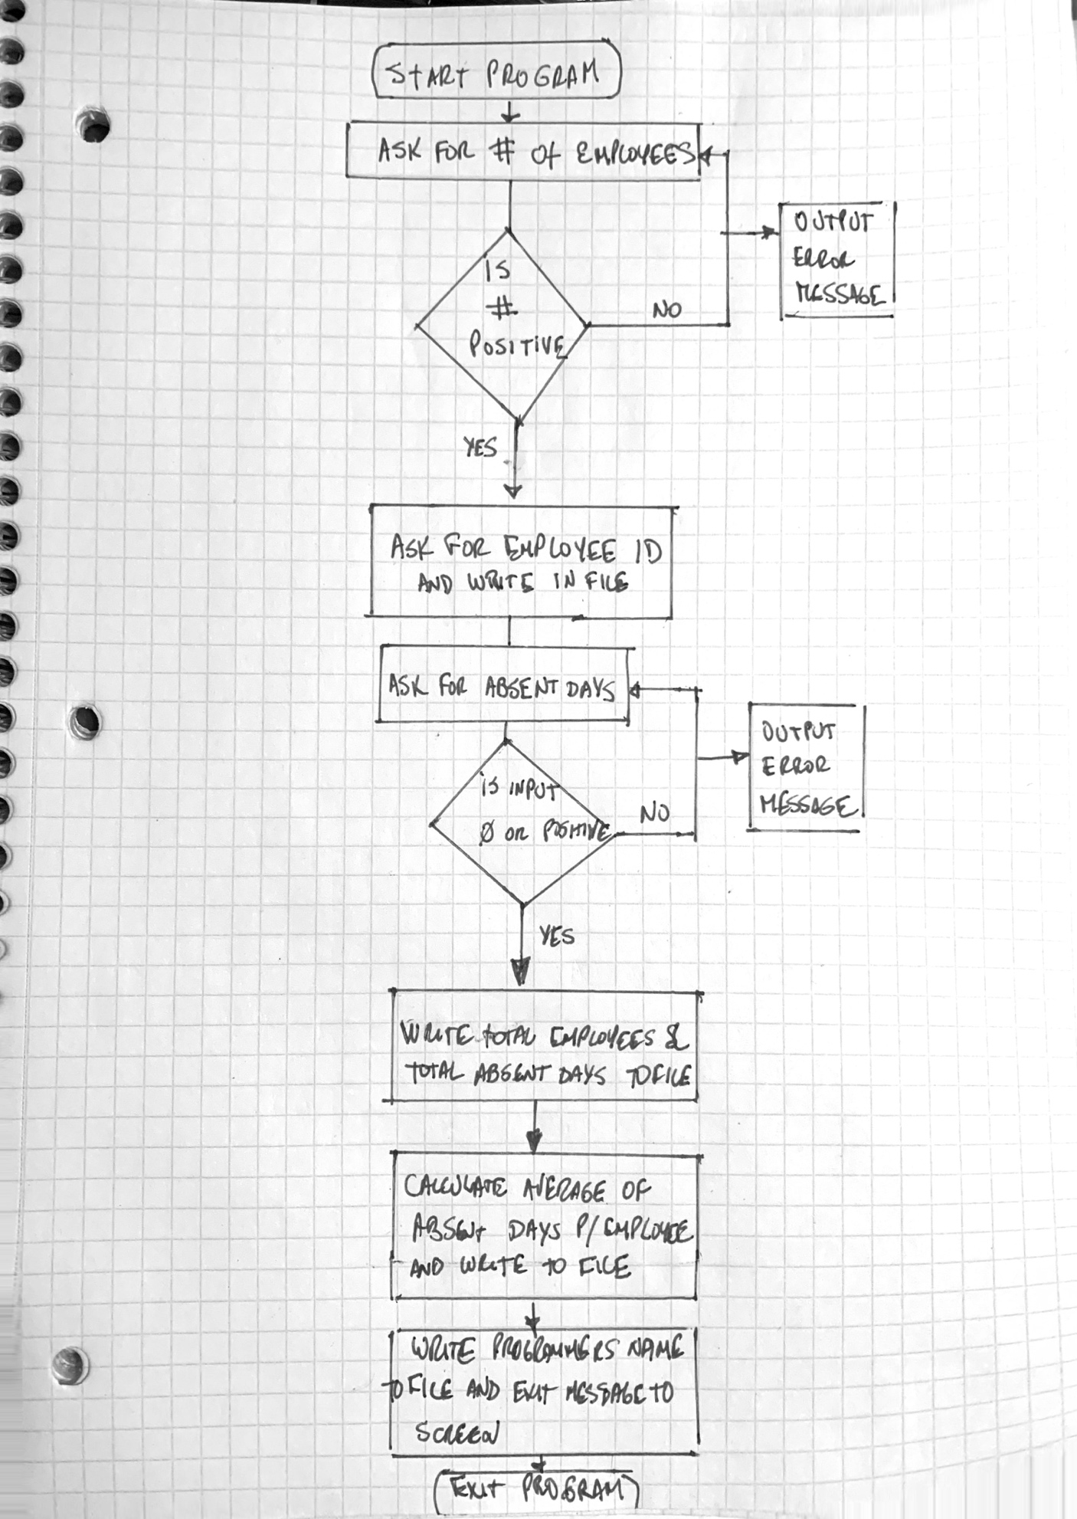

Lesson Learned:

When passing an ofstream file as a parameter to a function, you cannot pass it as you would pass an int or a double since these are primitive data types in C++. An oftream file is an object, and if you pass an object as a parameter, you are passing by value. This means you pass a copy of the object, not the object itself.

When you create an object, like: ofstream file(filename) the object is in memory, and file is a reference or a pointer to the object, like the address to your house.

When you pass this as parameter, you are creating a copy of your house, but it’s not the same house. If you modify this new object, this new house, if you go back to your house, it’s just like it was before, there’s no change.

So, if you want the object, like the ofstream, to be modified, you need to pass it by reference, which means, pass the pointer to the object. You this by writing this:

nameOfFunction(ofstream& file){

……….

}